Develop a python script
Publish Data to the IBM Cloud

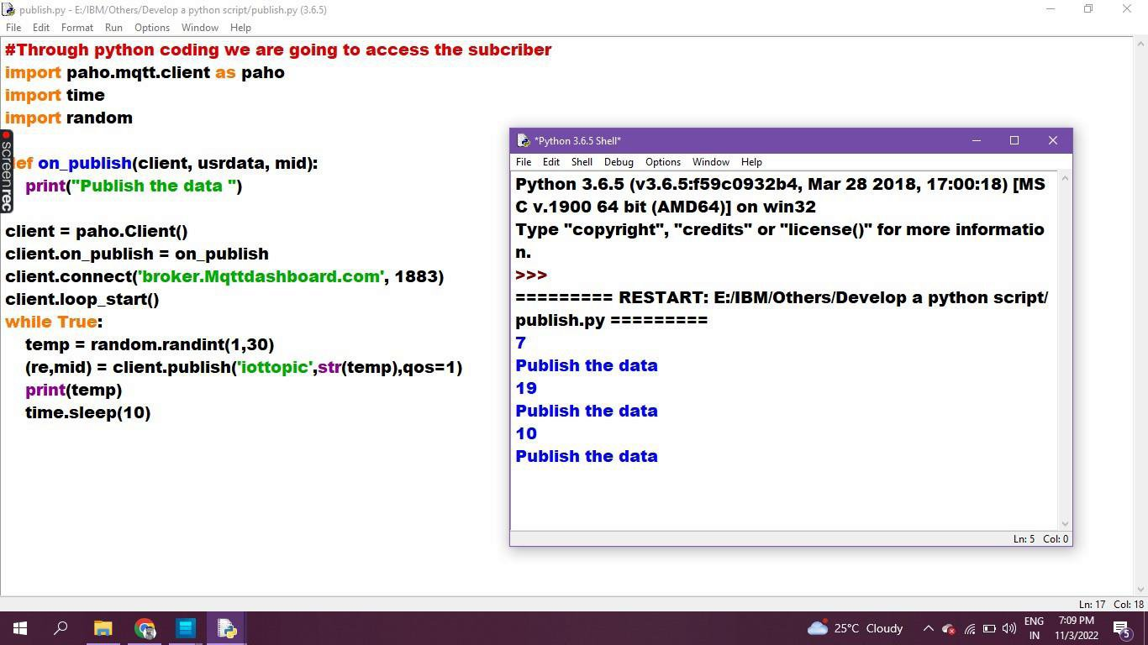
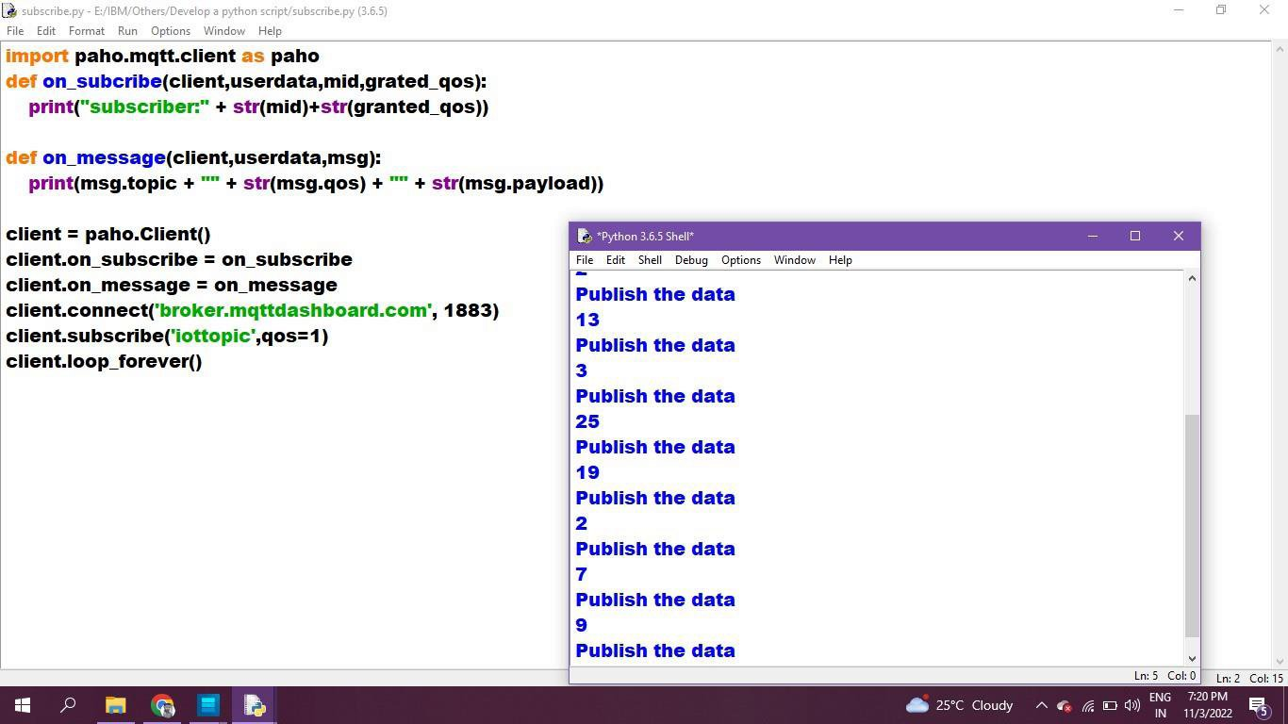
Signs with smart connectivity for Better road safety
Date | 22 November 2022
Team ID | PNT2022TMID44492
Project Name | Project - Signs with smart connectivity for Better road safety
Maximum Marks | 4 Marks
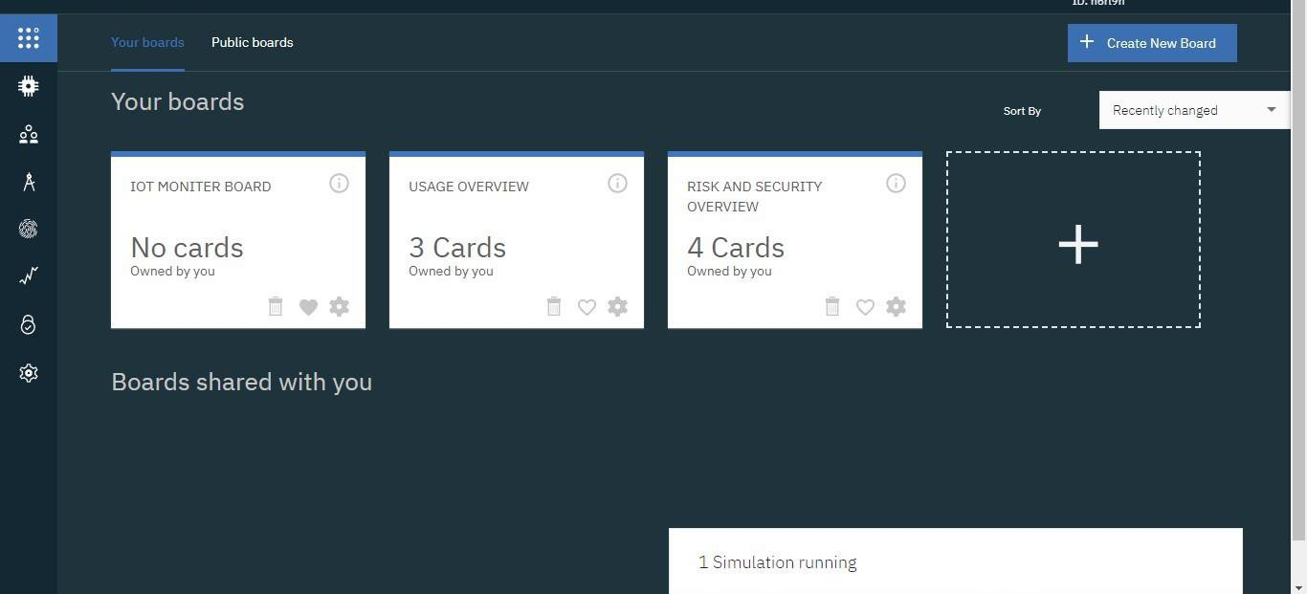
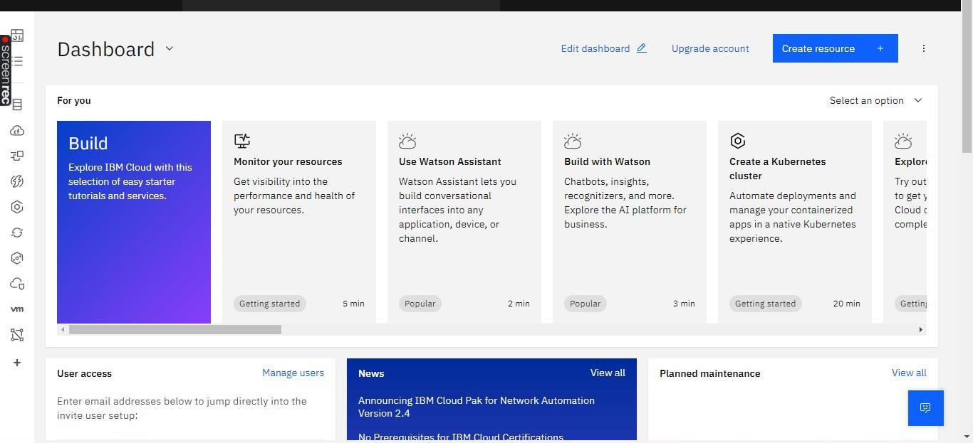

CODE:

#IBM Watson IOT Platform

#pip install wiotp-sdk

import wiotp.sdk.device

import time

import random

myConfig = {

"identity":{

"orgId": "hj5fmy",

"typeId": "NodeMCU",

"deviceId":"12345" },

"auth": {"token": "12345678" }

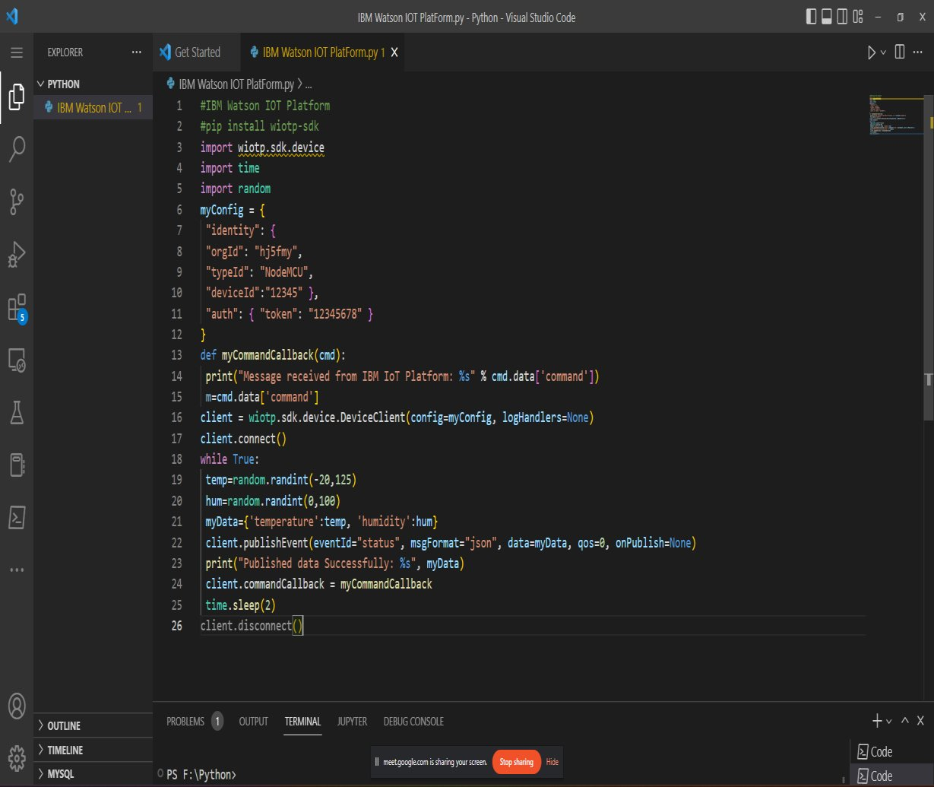
def myCommandCallback(cmd):
print("Message received from IBM IoT Platform: %s" % cmd.data['command'])

m-cmd.data['command"]

client = wiotp.sdk.device.DeviceClient(config=myConfig, logHandlers=None)

client.connect()

while True:

temp=random.randint(-20,125)

hum-random.randint(0,100)

myData={'temperature': temp, 'humidity':hum}

client.publishEvent(eventId="status", msgFormat="json", data=nyData, qos=0, onPublish=None) print("Published data Successfully: %s", myData)

client.commandCallback = myCommandCallback

time.sleep(2)

client.disconnect

